|  |  |  |  |  |  |  |
| --- | --- | --- | --- | --- | --- | --- |
| Document Title: **Specification, sound quality evaluation based on time-frequency analyze** | | | | | | |
| Document No: **001** | | | | |  | Rev: **1.0** |
|  | |  | | |  | GN ReSound as  Technology Research  Document |
| Orig. Author | | Chandler Chen | | | Apr 7th, 2017 |
| APPROVALS | | | | | |
| Approver 1 | | [initials] | | | [dd-mm-yyyy] |
| Approver 2 | | [initials] | | | [dd-mm-yyyy] |
| Approver 3 | | [initials] | | | [dd-mm-yyyy] |
| Document Revision History | | | | | | |
| REV | Issue Date | | Change Owner | Change Description | | |
| 1.0 | 2017-04-07 | | Chandler | Initial version | | |
|  |  | |  |  | | |
|  |  | |  |  | | |
|  |  | |  |  | | |
|  |  | |  |  | | |
|  |  | |  |  | | |
|  |  | |  |  | | |
|  |  | |  |  | | |
|  |  | |  |  | | |
|  |  | |  |  | | |
|  |  | |  |  | | |
|  |  | |  |  | | |
|  |  | |  |  | | |
|  |  | |  |  | | |
|  |  | |  |  | | |
|  |  | |  |  | | |
|  |  | |  |  | | |
|  |  | |  |  | | |
|  |  | |  |  | | |
|  |  | |  |  | | |
|  |  | |  |  | | |
|  |  | |  |  | | |
|  |  | |  |  | | |
|  |  | |  |  | | |
|  |  | |  |  | | |
|  |  | |  |  | | |
|  |  | |  |  | | |
|  |  | |  |  | | |
| These drawings and specifications, and the data contained therein, are the exclusive property of GN ReSound issued in strict confidence and shall not, without prior written permission of GN ReSound, be reproduced, copied or used for any purpose whatsoever, except the manufacture of articles for GN ReSound. | | | | | | |



Table of Contents

1. Overview 2

2. Proposals and implementation 2

2.1. Principle 2

2.2. Process 3

2.3. Examples 3

3. Function description 5

Overview

There is no standard and perfect way to evaluate HI sound quality. Normally, we will do distortion measurement and listening test. The distortion can indicate the fidelity of HI in a way, but we cannot locate the root cause. Listening test is too subjective, not quantifiable.

Therefore, it is necessary to develop a metering method. The correlation coefficient and time-frequency spectrogram are introduced. We can get the difference between output and source, also the noise can be located at what time and what frequency.

Proposals and implementation

## Principle

Correlation coefficient

It is a number that quantifies a type of correlation and dependence, meaning statistical relationships between two or more values in fundamental statistics.

Here, Pearson’s correlation coefficient is applied. It is the covariance of two variables divided by the product of their standard deviations.

$$ρ_{X,Y}=\frac{cov(X,Y)}{σ_{X}σ_{Y}}$$

When applied to a sample, Pearson’s correlation coefficient is commonly represented by the letter $r$. Assume we have one dataset $\left\{x_{1}⋯,x_{n}\right\}$ and $\left\{y_{1}⋯,y_{n}\right\}$, the formula for r is:

$$r=r_{xy}=\frac{n\sum{x_{i}y_{i}}-\sum{x_{i}}\sum{y_{i}}}{\sqrt{\left(\sum{x_{i}^{2}}-n{\overline{x}}^{2}\right)}\sqrt{\left(\sum{y_{i}^{2}}-n{\overline{y}}^{2}\right)}}$$

Spectrogram

It is a visual representation of the spectrum of frequencies in a sound or other signal as they vary with time or some other variable. Spectrograms are sometimes called spectral waterfalls, voiceprints or voicegrams.

Spectrogram are usually created in one or two ways: approximated as a filterbank that results from a series of band-pass filters (this was the only way before the advent of modern digital signal processing), or calculated from the time signal using the Fourier transform. These two methods actually form two different time-frequency representations, but are equivalent under some condtions.

The bandpass filters method usually uses analog process to divide the input signal into frequency bands; the magnitude of each filter’s output control a transducer that records the spectrogram as an image on paper. Creating a spectrogram using the FFT is a digital process. Digitally sampled data, in the time domain, is broken up into chunks, which usually overlap, and Fourier transformed to calculate the magnitude of the frequency spectrum for each chunk. Each chunk then corresponds to a vertical line in the image; a measurement of magnitude versus frequency for a specific moment in time (the midpoint of the chunk). These spectrums or time plots are then “laid side by side” to form the image or a three-dimensional surface, or slightly overlapped in various ways, i.e. windowing. This process essentially corresponds to computing the squared magnitude of the short-time Fourier transform (STFT) of the signal s(t) – that is, for a window width w, spectrogram(t,w) = |STFT(t,w)|2.

## Process

How does this system work?

Distortion cannot locate the frequency of noise, and it is hard to separate target signal from spectrum when there is disturbance signal, like floor noise.

But it is easier to locate target signal from power spectrum in time-frequency field.

Analyse the spectrogram of signals, and find the difference among them.

Calculate the correlation coefficient in statistics. This coefficient can quantify the sound quality, like distortion. Spectrogram locates the noise.

## Examples

Sound source is a speech.

We assume there is a good HI without floor noise, but the system makes a single frequency noise, like 2K Hz.

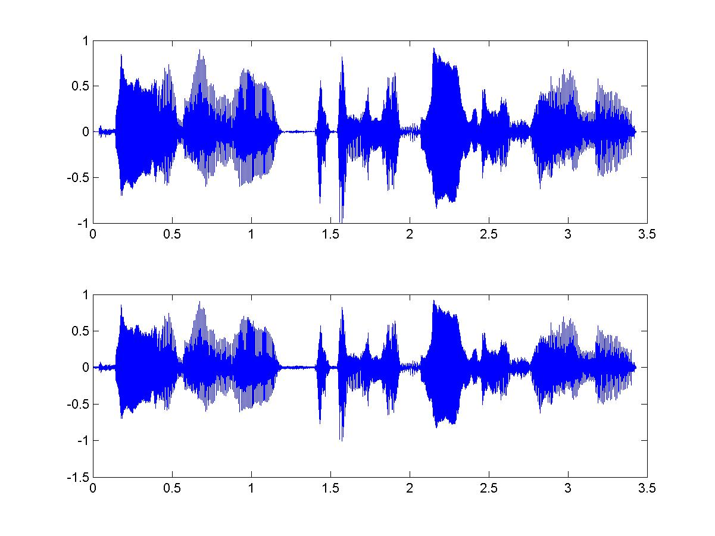

*Source vs. output (time field /s)*

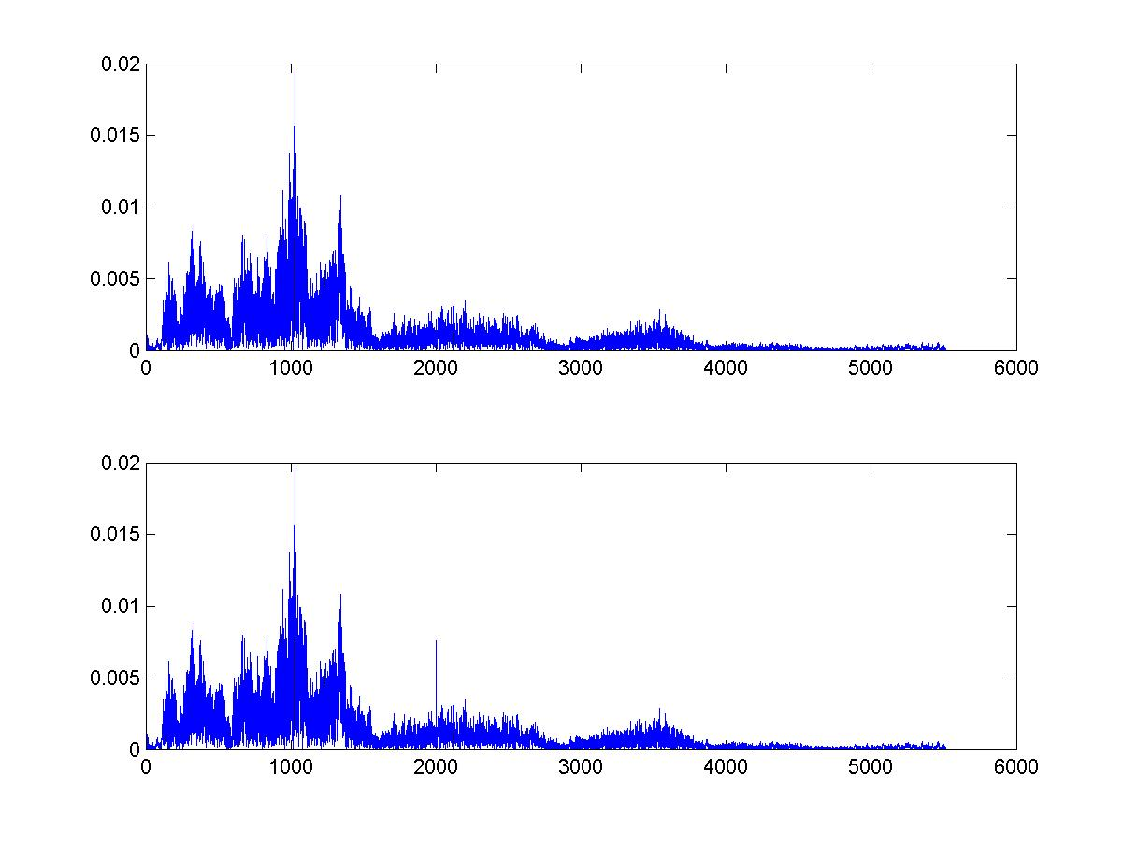

*Source vs. output (frequency field /Hz)*

From the figure above, the target 2k Hz signal is hidden in the spectrum.

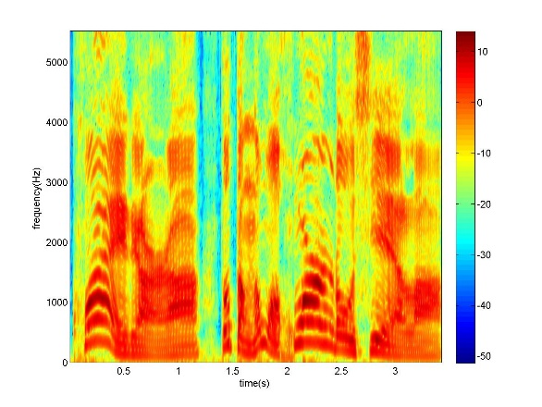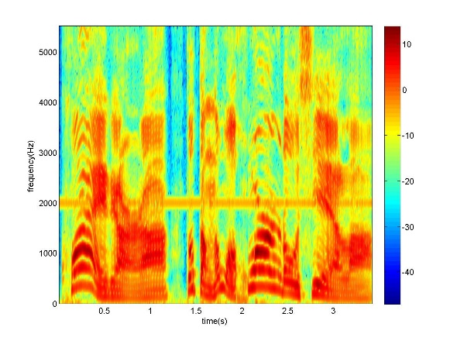

*Source vs. output (temporal-frequency spectrogram/Power)*

From the above power spectrogram, we can locate the target time and frequency in naked eye.

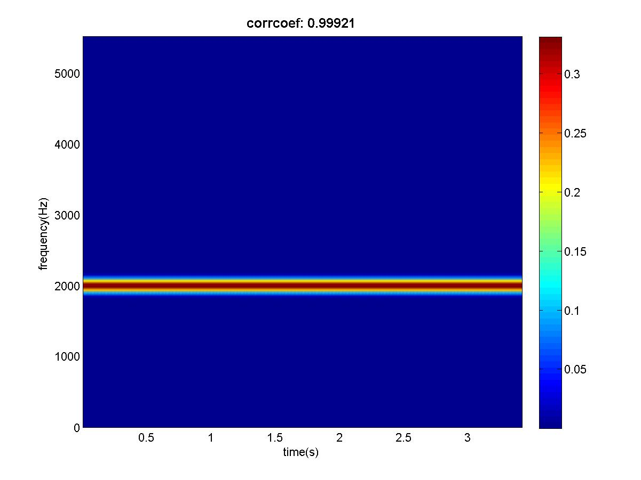

The correlation coefficient is 0.99921, and we can locate the 2k Hz noise from this power difference figure with no difficulty.

The conclusion of this evaluation is: the correlation of 2 signals is high enough to be same, but there is one single frequency noise made in HI system.

Evaluate HI system:

Speaker plays a sound wave file – collect by HI microphone – HI system – output

Compare HI output and sound source in time-frequency field.

Calculate the correlation coefficient of these two signals.

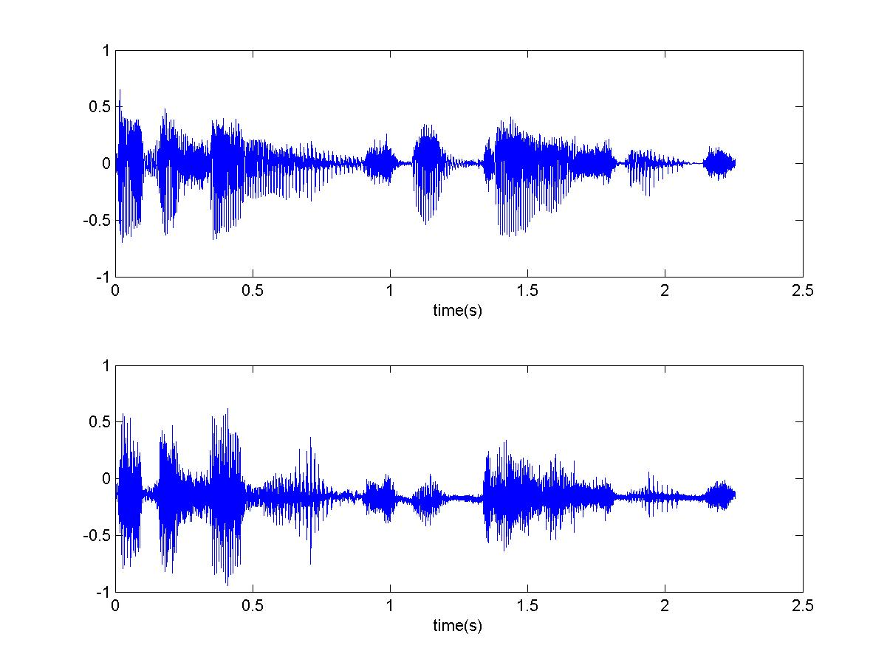

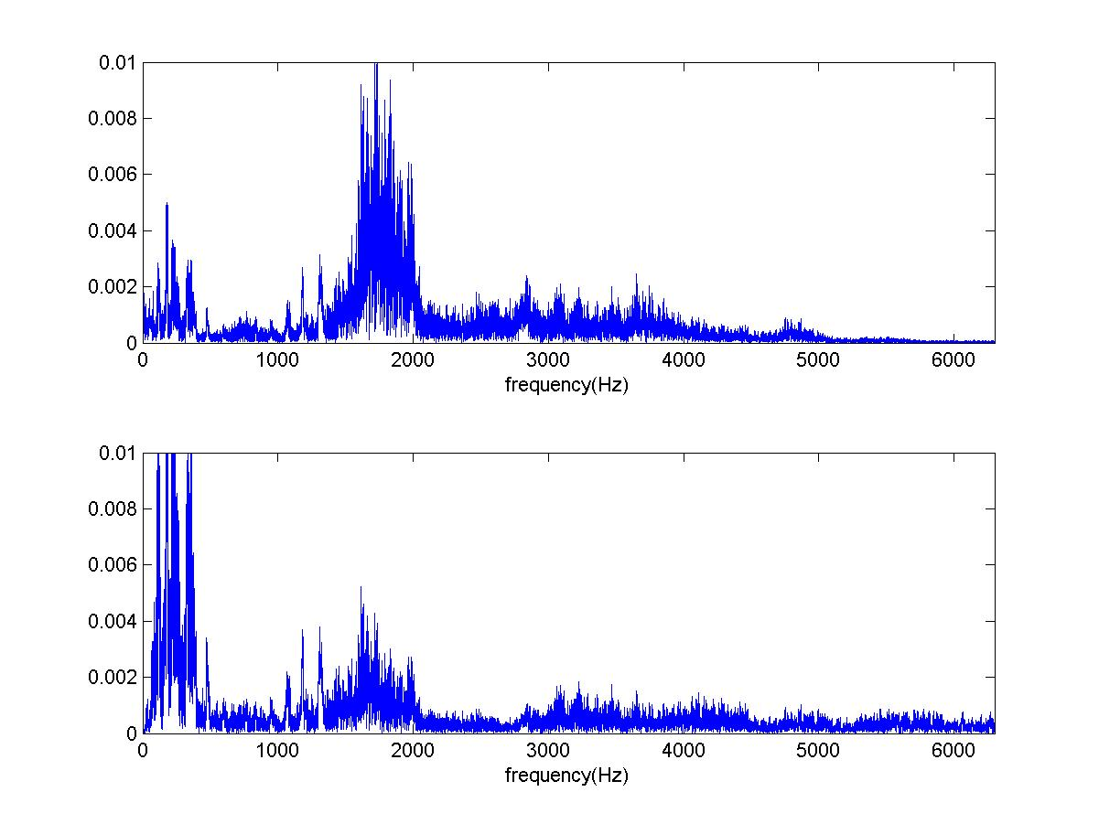

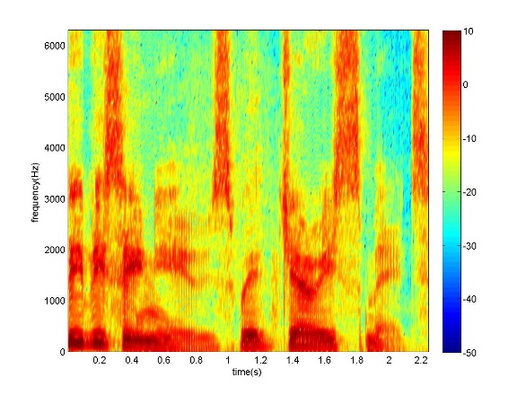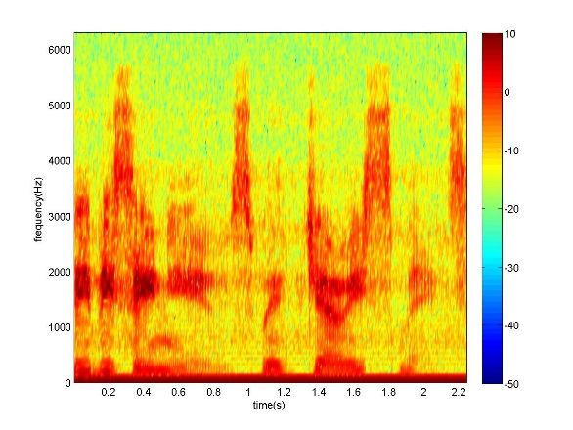

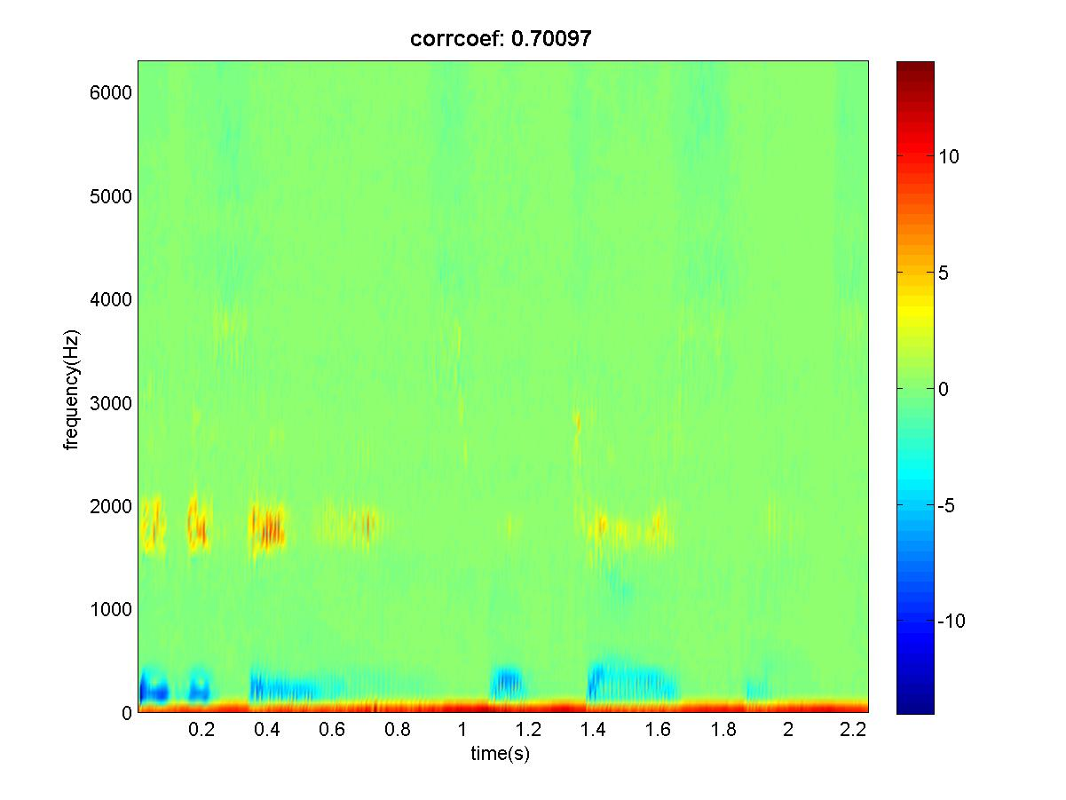

Function description

xxx